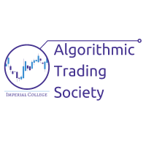

Algorithmic Society- Trading Platform Visualisation

The purpose of the algorithmic trading platform will be to provide a proof of concept of the trading platform for the Imperial College Algorithmic Trading Society.

The algorithmic trading platform is aimed to allow data to be taken in, algorithms to be run against that data. The data will be pulled from various APIs, preferably of the user choice, and robust code will ensure that the format is correct.

# Background

Data Visualisation is important to allow any dataset currently to be displayed graphically. The extension to this part of the program will be having an option to add signals output by the algorithm (200 day averages etc).

# Goals

* Setup and understand the visualisation element of the trading platform
* Develop the trading platform to view a sample dataset
* Improve the GUI to display data with more complex UI elements

# Setup

Programs to Install

|  |  |  |  |
| --- | --- | --- | --- |
| Applications | Description | Purpose | Notes |
| Pyqt |  |  |  |
| QtDesigner | GUI Designer | Generates XML based off a design | .ui file is generated can be seen in the file |

Milestones